**Listen to Jesus**

**Reading:** Matthew 7:24-27

Jesus said, “Everyone who hears my words and puts them into practice is like a wise man. He builds his house on the rock. The rain comes down. The water rises. The winds blow and beat against that house. But it does not fall. It is built on the rock. But everyone who hears my words and does not put them into practice is like a foolish man. He builds his house on sand the rain comes down. The water rises. The winds blow and beat against that house. And it falls with a loud crash.”

**Thought about the reading**

Three years ago, we had a new room built at the back of our house. I watched the builders as they worked. The first thing they did was to dig a trench and fill it with concrete. This was the foundation for the walls. It was like building on a rock. If they had filled the trench with sand, then the walls would have fallen over very quickly. Happily, they are still standing firm!

Jesus says that we need to listen to what he says and then we need to do what he says. If we do that, we are like the wise man who built his house on the rock. When things get difficult, we can stand firm, knowing that Jesus is looking after us.

But if we do not do what Jesus tells us, then we are like the foolish man building on sand. When things get difficult, everything will fall with a loud crash.

How do we know what Jesus is telling us to do? We can read what he said in the Bible.

Jesus does not just tell us what to do – he also gives us help to do it. He gives us his Holy Spirit who helps us to remember what he said, and he gives us strength to put it into practice.

**Prayer**

Lord Jesus, thank you for all the things you have told us in the Bible.

Please send your Holy Spirit to help me remember what you have told me and to help me put it onto practice.

When things are difficult, please help me to remember that you are looking after me.

Amen

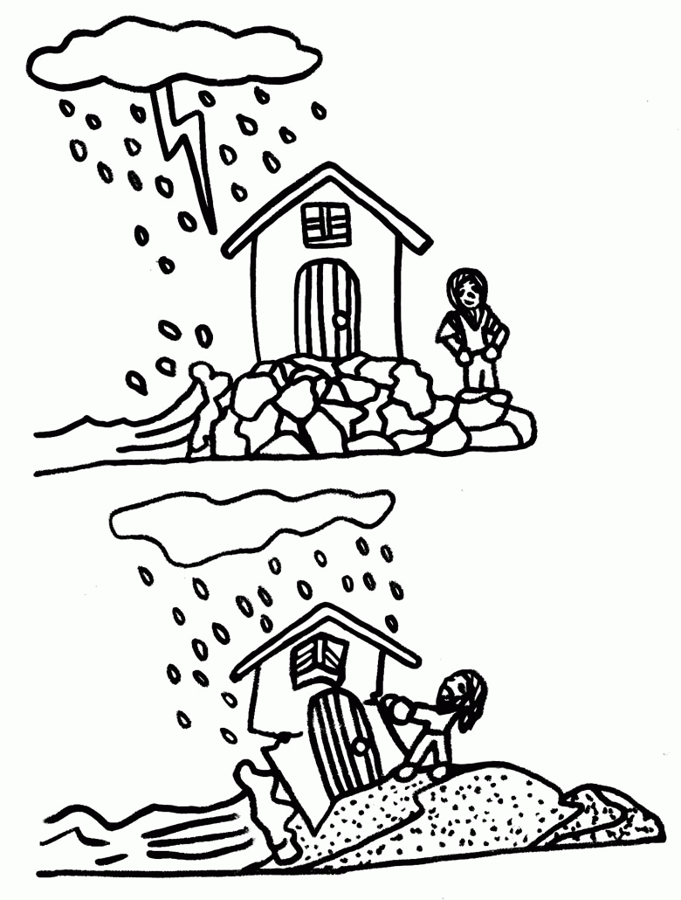

**Cambridge Causeway**

Summer 2023

Bible Study notes

**The Sermon on the Mount**

**6. Listen to Jesus**

By Chrissy Cole